|  |  |
| --- | --- |
|  |  |

**Merchant Integration UAT Script**

**Version 1.0**

**Merchant Name:**

History

|  |  |  |
| --- | --- | --- |
| **Date** | **Updated By** | **Description** |
|  |  | **INITIAL RELEASE** |

# Table of Contents

1. Table of Contents 2

2. Inquiry Transaction 3

3. Payment Notification 5

***Notes:***

1. ***Please provide full flow positive test screenshots, starting from choosing a product -> checkout -> payment and success page***
2. ***For each signature field in this test case, will be filled in by merchant’s tester, then the result must be sent to ESPAY team. This will be your proof for doing this UAT.***
3. ***For actual result, please fill in your result with reference image name (e.g: picture 1) and provide the screenshot on the last page of this document.***
4. ***For production needs, please inform us your inquiry and or payment notification URL along with your customer service email that will be registered in production***
5. ***The completed documents can be sent to the following email address:***

[***kresna@sgo.co.id***](mailto:kresna@sgo.co.id)

[***samuel@sgo.co.id***](mailto:samuel@sgo.co.id)

[***ivan@sgo.co.id***](mailto:ivan@sgo.co.id)

[***anang@sgo.co.id***](mailto:anang@sgo.co.id)

# Inquiry Transaction

|  |  |  |  |
| --- | --- | --- | --- |
| **Module Name :** | Inquiry Transaction | **Testing Date :** |  |
| **Tester Name :** |  | **Signature** |  |

| **Step No.** | **Actions** | **Steps** | **Expected Result** | **Pass / Fail** | **Actual Result** |
| --- | --- | --- | --- | --- | --- |
|  | Inquiry Transaction | * Click checkout/payment button from merchant website   **[NEGATIVE TEST]**   * Invalid Inquiry Transaction URL * Invalid API Key * Invalid Password * Invalid Signature * Inquiry Format Response from Merchant does not match with Espay Technical Specification Document | * Successfully redirect to bank web page (espay) * Error Notification [0031] Rejected, Error komunikasi dengan Mitra appears * ESPAY Payment method does not show up at checkout page * Error Notification [0031] Rejected, Error komunikasi dengan Mitra appears * Error Notification [0031] Rejected, Error komunikasi dengan Mitra appears * Error Notification [0031] Rejected, Error komunikasi dengan Mitra appears |  |  |

# Payment Notification

|  |  |  |  |
| --- | --- | --- | --- |
| **Module Name :** | Payment Notification | **Testing Date :** |  |
| **Tester Name :** |  | **Signature** |  |

| **Step No.** | **Actions** | **Steps** | **Expected Result** | **Pass / Fail** | **Actual Result** |
| --- | --- | --- | --- | --- | --- |
| 1 | Payment Notification | * Login to <https://sandbox-portal.espay.id/> using customer id, user id and password which Merchant get from Espay * Choose Simulation Menu -> Choose payment channel which merchant wants to use (e.g: Permata ATM) -> input virtual account number -> submit   **[NEGATIVE TEST]**   * Invalid URL Payment Notification * Invalid Signature * Invalid Password * Invalid hashing signature * Inquiry response Format from Merchant does not match with Espay Technical Specification Document * Doing payment notification twice with same payment ref | * Successfully Login to Espay Dashboard Page * Payment is Success * Payment will have Suspect status with error notes PR31 * Payment will have Suspect status with error notes PR31 * Payment will have Suspect status with error notes PR31 * Payment will have Suspect status with error notes PR31 * Payment will have Suspect status with error notes PR31 * Merchant will response with error_code which is not 0 (zero) and error_message=double payment or Transaksi ID tidak ditemukan (Transaction ID not found) |  |  |

# Especially for merchant who wants to use “Credit Card” channel that is AGGREGATOR must publish “ESPAY” word on merchant’s credit card billing statement. (on UAT please provide your screenshot)

# Example:

Dear Customer,

For payment with Credit Card , on behalf of the bill that printed out will have [**ESPAY**](http://espay.id/) word on it.

step 1, checkout

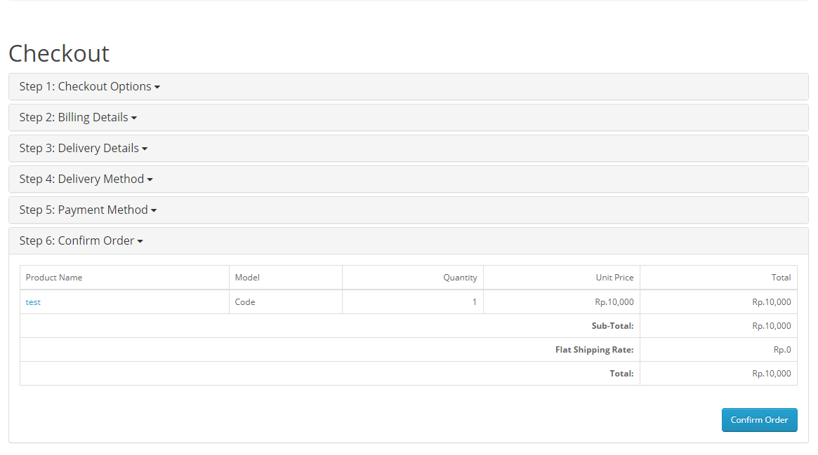

step 2, enter the payment page



step 3, the bank transfer page

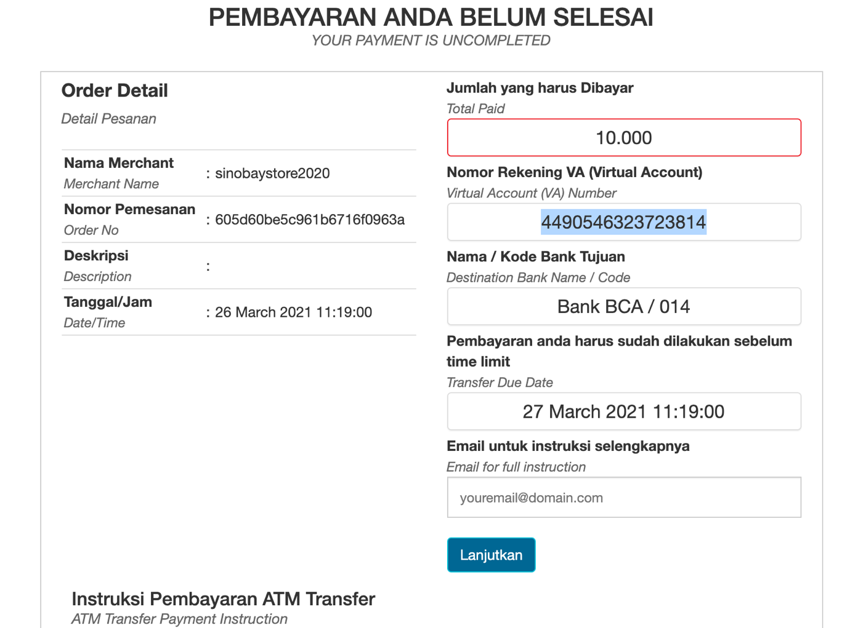

step 4, Notification page

